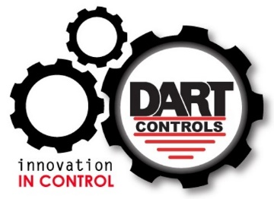
Dart Controls Application Note

Take-Up / Take-Off Control

A very common application for Dart MD Series (MD3 / MD10 / MD40 / MD50) digital DC drives is the need to transfer product from one roll or reel to another. Examples include wire extruding/heat treatment, web laminating/coating, and converting where a large (wide) roll of material is split into smaller or narrower rolls.
The primary control requirement is for constant (material) speed regardless of roll diameter. Said another way, as material accumulates on the (take up) reel, the motor driving the reel needs to slow down to keep the perimeter speed where the (material) is being added constant.
Here is a picture of the process:
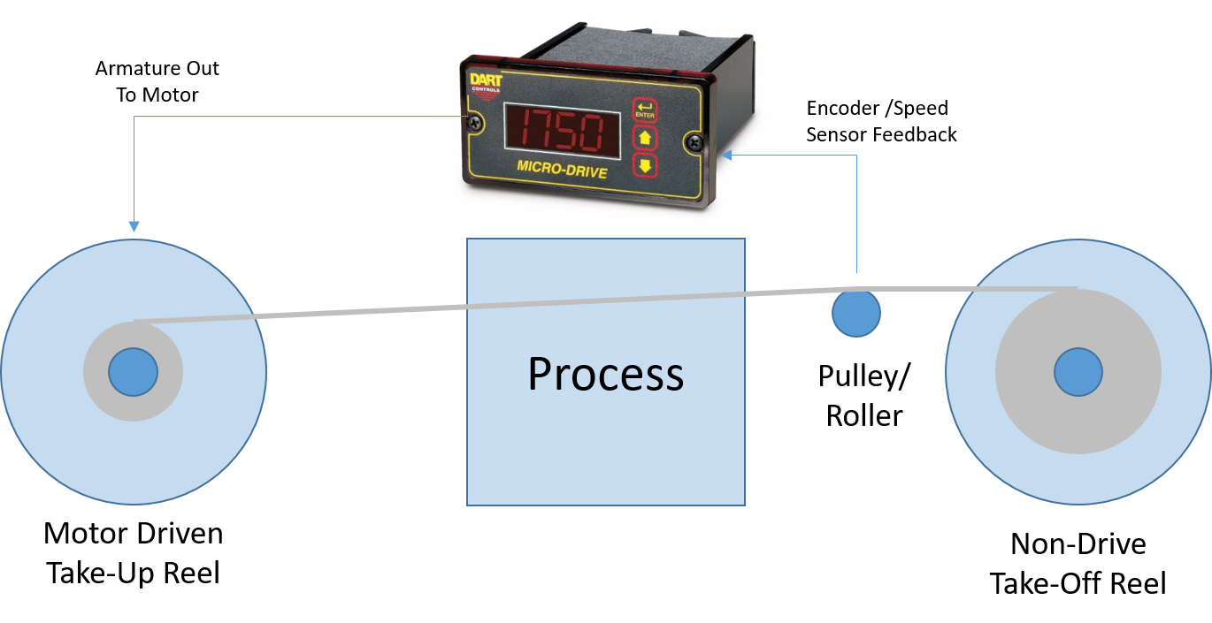
The MD Series is especially suited for this application – closed-loop digital control keeps the speed constant under changing conditions. Notice the required encoder feedback is placed at an idler roll or pulley where material speed is not affected by take-up or take-off reel diameter. As the diameter of the accumulated material on the take-up reel increases, the tendency is for the material to speed up. The encoder will tell this to the MD control, which will in turn slow the motor on the take-up reel accordingly. An important BONUS: The MD display may be scaled in in/min or ft/min so the operator knows exactly how fast the material is moving, without having to make calculations or use a conversion chart.
These applications are generally low speed, so care must be taken when selecting the encoder. A Dart PU Series encoder may not generate enough pulses/rev (20 max) for the MD Series control to work. In general, ALL MD (and ASP Series) controls need a minimum of 500 pulses/min to regulate speed efficiently. That means the minimum RPM of the location of the encoder must be greater than ~25RPM. If a third party encoder is needed, here are the specifications:
- Incremental type (not absolute)
- 5-24VDC, with 5VDC preferred so it may use the MD power supply provided
- Open collector / NPN / sinking source
- Pulse/revolution output such that at lowest speed output equals / greater than 500 pulses/min, AND:
  - Not more than 50,000 pulses/min for MD3 / MD10 / ASP10
  - Not more than 600,000 pulses/min for MD40 / MD50 / ASP40

